**11-7 notes**

Introduction to SQL

Goals:

By the end of this lesson, you will be able to:

* Run Postgres and pgAdmin.
* Create a SQL database and its tables by using pgAdmin.
* Define SQL data types, primary keys, and unique values.
* Load the data from CSV files into a database and then query the data.
* Explain the four basic functions of persistent storage—create, read, update, delete (CRUD)—and apply them to a database.
* Combine the data from multiple tables by using JOIN clauses.

Using Postgres PGadmin4

SQL stands for Structured Query Language

RDBMS is Relational Database Management System

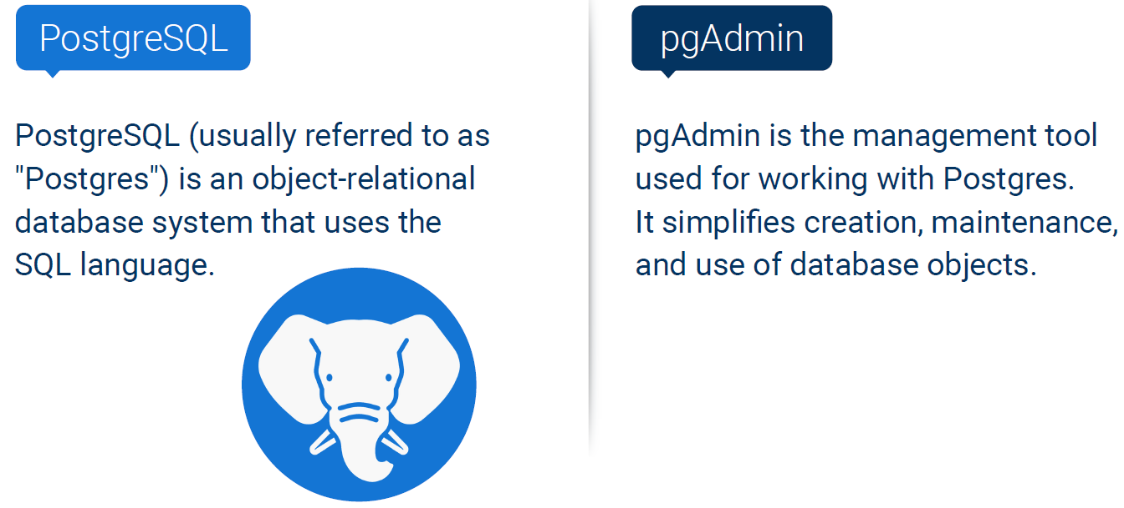

In pgAdmin, Right click database, then select Query tool to get to a space where you can type code.

Tables are under schemas

Select * from people

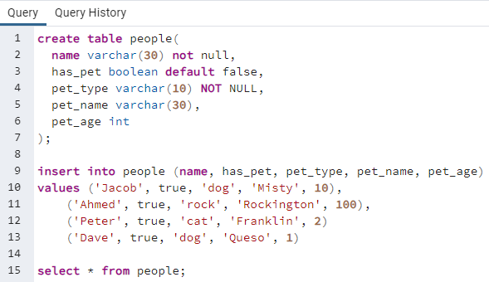

Highlight rows to run them. Default is to run all the rows, top to bottom

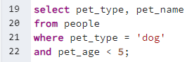

You can copy code over to scratch pad on right to get it out of the area with the code you want to run.

**Select ___ From ___ Where ___ And ___ Or__**

SQL doesn’t care about upper or lower case.

Very common to not use any capitalization in code (except when inserting names into tables)

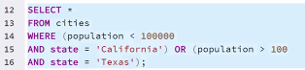

* (Asterisk) is a wildcard character. It stands for ALL in “Select *”

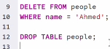

^ Drop table deletes the table.



**CRUD:**

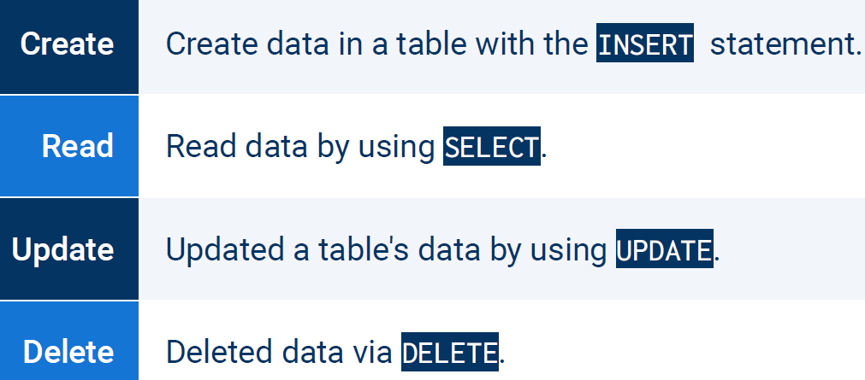

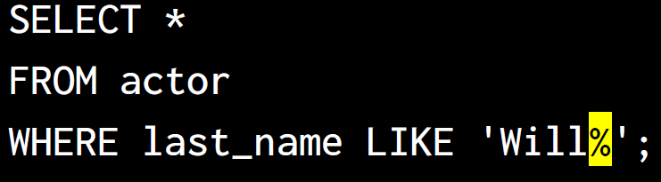

^ Wildcard character % will substitute zero, one, or multiple characters in a query.

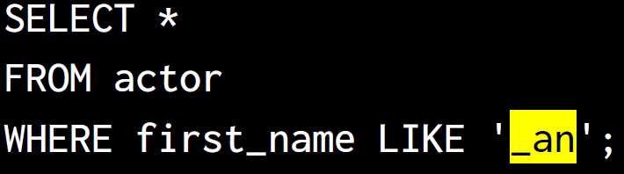

^ Wildcard character _ will substitute only **one** character in a query.

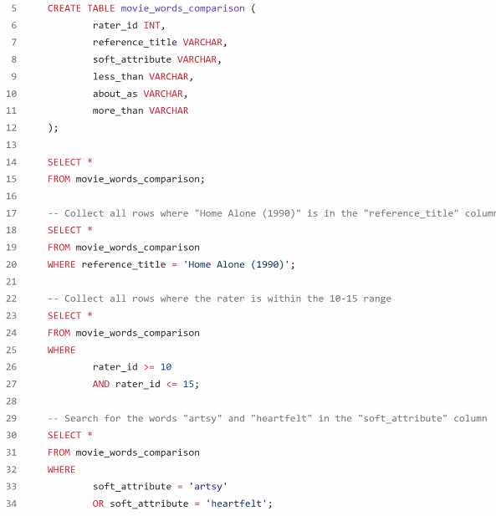

!= means NOT equal

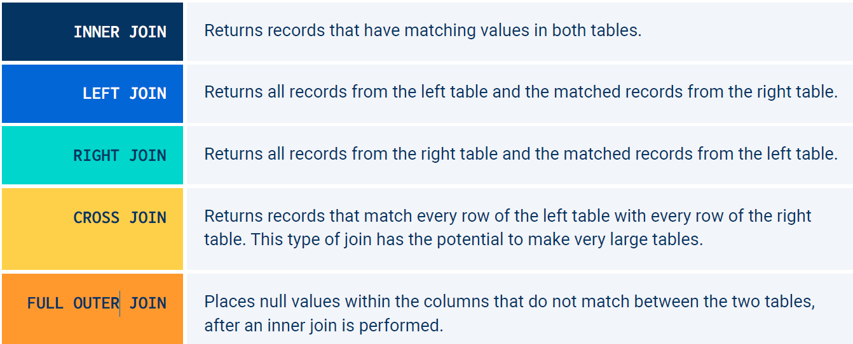

^ Cross join is also called cartesian join. It’s a combo of a left join and a right join smashed into one.

^full outer is like a combo of Left, Right, and Inner joins.

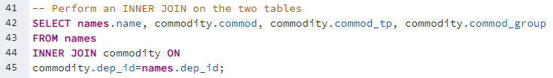

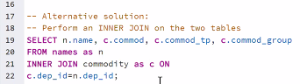

^ Line 20 and 21 designates n as an alias for names, and c as an alias for commodity

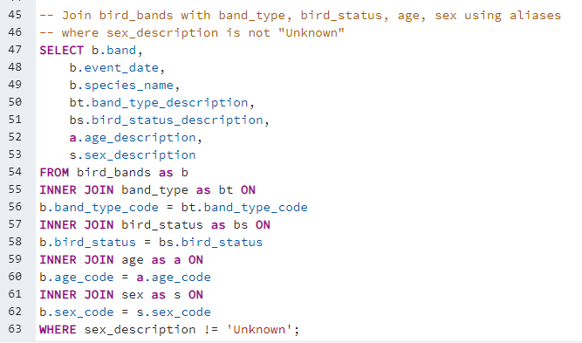

^ above is